

REAL-TIME CODE COLLABORATION

A PROJECT REPORT

Submitted by

VISHNURAJU V (22IT056)

JOTHEESHWARAN M (22ITL02)

VIGNESHWARAN M (22ITL08)

In partial fulfillment for the award of the degree of

BACHELOR OF TECHNOLOGY
in

INFORMATION TECHNOLOGY

NANDHA ENGINEERING COLLEGE
(An Autonomous Institution, Affiliated to Anna University, Chennai)

ERODE – 638 052

MAY 2026

NANDHA ENGINEERING COLLEGE
(An Autonomous Institution, Affiliated to Anna University, Chennai)
ERODE - 638 052

BONAFIDE CERTIFICATE

This is to certify that the project report entitled “REAL-TIME CODE COLLABORATION” is the bonafide record of project work done by VISHNURAJU V (22IT056), JOTHEESHWARAN M (22ITL02),
VIGNESHWARAN M (22ITL08) in partial fulfillment of the requirements for the award of the Degree of Bachelor of Technology in INFORMATION TECHNOLOGY of Anna University, Chennai during the year 2025-26.

SUPERVISOR
Mr. R. RAGUNATH, M.E.
Assistant Professor, Department of IT,
Nandha Engineering College, Erode 638 052.
HEAD OF THE DEPARTMENT Dr. G. R. SREEKANTH, M.E, Ph.D
Professor and Head of Department, Department of IT,
Nandha Engineering College, Erode 638 052.

Submitted for the End Semester 22ITD01- Project Work Viva-Voce Examination
held on ……………

Internal Examiner External Examiner

ACKNOWLEDGEMENT

We first and foremost, our heartful thanks to our Parents for giving us an opportunity to do this engineering course successfully.
We wish to express profound gratitude to Thiru. V. Shanmugan, Chairman, Sri Nandha Educational Trust, Thiru. S. Nandhakumar Pradeep, Joint Managing Trustee, Sri Nandha Educational Trust and Thiru. S. Thirumoorthi, Joint Managing Trustee, Sri Nandha Educational Trust for providing opportunities in all possible ways for our improvement.
We wish to convey our gratefulness to our beloved Principal, Dr. U. S. Ragupathy, Ph.D. for his strong support and motivation towards a great level of success in our career.
We take this opportunity to express our thanks to our beloved Head of the Department, Dr. G. R. Sreekanth, Ph.D for his help and encouragement.
We articulate our genuine thanks to our Project Co-ordinator, Mr. R. Anand, Assistant Professor who have been the key spring of motivation to us throughout the completion of our course and project work.
We sincerely thank our Supervisor, Mr. R. Ragunath, M.E, Assistant Professor, Department of Information Technology for his valuable guidance to complete this project.
We express our sincere thanks to all Information Technology Department Faculty Members for their help in completing this project.

CHAPTER NO
TABLE OF CONTENTS
TITLE PAGE NO

ABSTRACT
LIST OF FIGURES
LIST OF ABBREVIATIONS
- INTRODUCTION 1
  - NEED FOR THE STUDY 2
  - OBJECTIVES FOR THE STUDY 3
- REVIEW OF LITERATURE 4
  - TECHNOLOGICAL ACHIVEMENT 6
  - IMPACT ON CUSTOMER EXPERIENCE & EFFICIENCY
8
- PROJECT LIFECYCLE 9
- WORKFLOW OF PATIENT DATA MODULE 12
- LANGUAGES USED 14
- HARDWARE AND SOFTWARE REQUIREMENTS
- HARDWARE 16
- SOFTWARE 16
- MODULES
  - MODULE DESCRIPTIONS
    - WORKING PROCESS 18
    - CONTROLS 22
RESULTING CONFIGURATION AND
- OUTCOMES 25

- APPLICATIONS OF THE PROJECT 28
- SOURCE CODE
  - APP.PY 30
  - AUDIO_PROCESSOR.PY 31
  - DATABASE.PY 32
  - NOTIFIER.PY 33
  - ML_MODEL.PY 35
  - TRAIN_DATASET.PY 36
  - GENERATE_APPLIANCE_DATA.PY 38
  - GENERATE_TEST_DATA.PY 39
- PROJECT SCREENSHOTS 41
- CONCLUSION 44
- REFERENCES 45

ABSTRACT
Collaborative coding in real time has become essential to distributed software development, as the tools available to developers face issues with latency, merge conflicts, and a lack of visibility into concurrent edits, resulting in decreased productivity and increased coordination costs. This paper introduces an AI-based collaborative code-editing platform that integrates Temporal Edit Pattern Learning (TEPL) with an adaptive Conflict-free Replicated Data Type (CRDT) synchronization framework. The system captures developer actions, file modifications, and the location of code in temporal event streams. A lightweight model of TEPL analyse these temporal event streams to identify collaborative patterns for each developer, allowing the system to predict conflicts before they occur. The adaptive CRDT ensures that all users have a consistent view of the same document and reduces network latency when performing edits on it. Other features of the system include real-time tracking of cursors across users, built-in communication between team members and secure execution of code within a containerized environment (sandbox). The proposed model shows an 80-93% decrease in edit conflicts, an increased synchronization efficiency of 400Mbps, and a response time of 200ms, allowing scalable, real-time, multiple-user collaboration. The proposed framework provides a smart, responsive, and secure environment suited to teams engaged in distributed software development.

LIST OF FIGURES

S.NO | FIG.NO | DESCRIPTION | PAGE.NO
1. | 4.1 | work flow chart of Patient Data Module | 11
2. | 11.1 | Server running on port 5173 | 84
3. | 11.2 | Log in page Interface
4. | 11.3 | Code Editor Interface with Live Collaboration | 85
5. | 11.4 | Real-Time Code Synchronization View
6. | 11.5 | Room Creation and Joining Interface | 86
7. | 11.6 | Database Structure (MongoDB Collections)
8. | 11.7 | Real-Time Communication using WebSocket | 87

LIST OF ABBREVIATIONS

S.NO | SYMBOLS/ ABBREVIATIONS | EXPANSION
1. | REACT JS | JavaScript Library for Building User Interfaces
2. | CSS | Cascading Style Sheets
3. | JS | JavaScript
4. | CSS | Cascading Style Sheets
5. | ID | Identifier
6. | CRUD | Create, Read, Update, Delete
7. | RESTful API | Representational State Transfer Application Programming Interface
8. | JSX | JavaScript XML (Syntax Extension for React)
9. | SPA | Single Page Application
10. | HTTP | Hypertext Transfer Protocol
11. | JSON | JavaScript Object Notation
12. | DB | Database
13. | UI / UX | User Interface, and UX stands for User Experience
14. | NPM | Node Package Manager
15. | AJAX | Asynchronous JavaScript and XML
16. | RAM | Random access memory
17. | GB | Gigabyte
18. | API | Application Programming Interface
19. | OOP | Object-Oriented Programming

- INTRODUCTION

The increasing prevalence of distributed and remote software development teams, along with the need for real-time collaboration in coding environments, has also greatly increased. Modern software development workflows often require collaboration among geographically distributed developers to coordinate code changes, share information, and resolve problems efficiently.

There are many ways to provide developers with collaborative tools to work together on projects; however, asynchronous collaboration has been used most commonly and this type of collaboration is reliant on version control systems that use push and pull cycles, which can result in delays in the synchronization of code created by multiple users and create a high incidence of merge conflicts when multiple users edit the same segment of code concurrently.

Many collaborative coding tools have been created to mitigate these problems; however, many still suffer from high synchronization latency, a lack of awareness team-based project development using GenAI tools.

The model was tested with 30PG students working in teams on IoT projects, and the results show high learning perception (40% agree, 60% strongly agree). However, the model suffers from latency issues. Park et al. [5] present CpdeDive, a cloud-based collaborative programming platform with eWatcher to track students' coding behaviour and ensure academic integrity in LLMs. The model used a 100-student dataset rate.

The system consists of three distinct interfaces:

- User Portal: For developers to register, login, and join or create coding rooms.

- Dashboard: For managing users, monitoring active sessions, and controlling collaboration activities.

- Real-Time Collaboration Engine: For synchronizing code, managing live editing, and sharing updates instantly among users using WebSockets.

1.1 Need for the Study

Traditional coding environments and development workflows often rely on offline coding and delayed collaboration using version control systems, which can lead to:

    - Inefficient team collaboration and communication delays.
    - Difficulty in tracking real-time code changes.
    - Merge conflicts and version management issues.
    - Reduced productivity in remote development environments.
    - Limited interaction among team members.
    - Challenges in managing shared coding sessions.
    - Lack of instant feedback during coding. The System addresses these challenges through:
    - Real-time code synchronization using WebSockets.
    - Instant collaboration in shared coding rooms.
    - Live cursor tracking and user presence visibility.
    - Integrated chat system for communication.
    - Efficient code execution and output sharing.
    - Centralized data storage for code and sessions

Objectives of the Study

The primary objectives of developing the Real-Time Code Collaboration Platform are:

    - To develop a fully web-based platform for collaborative coding.
    - To enable multiple users to write and edit code simultaneously in real time.
    - To reduce development delays through instant code sharing and updates.
    - To provide real-time communication using chat features.
    - To allow users to create and join coding rooms easily.
    - To implement secure and efficient code execution.
    - To maintain a structured database of users, sessions, and code history.
    - To improve team productivity and collaboration efficiency.

2.REVIEW OF LITERATURE

COLLABORATIVE CODING SYSTEMS

Real-time code collaboration platforms are designed to allow multiple developers to work together on the same code simultaneously. These systems improve productivity by enabling instant communication, shared editing, and faster development cycles. Tools like collaborative editors use WebSocket technology to synchronize code changes in real time, ensuring that all users see updates instantly. These platforms are widely used in software development, education, and remote teamwork environments.

Modern collaborative systems also integrate features such as chat, version control, and live cursor tracking. These features help developers understand changes made by others and reduce conflicts during coding. Cloud-based architectures allow users to access the platform from anywhere, making collaboration more flexible and efficient.

CLOUD-BASED DEVELOPMENT PLATFORMS

Cloud-based development environments provide users with the ability to write, run, and manage code without installing software locally. These platforms use server-side execution and containerization to run code securely. Developers can collaborate in shared environments, test applications, and deploy projects easily. Such systems improve scalability and accessibility while reducing system dependency issues. Integration with cloud storage ensures that code is saved and accessible at any time. These platforms are especially useful for remote teams and educational institutions.

2.1TECHNOLOGICAL ACHIVEMENT

The Real-Time Code Collaboration Platform uses modern technologies and innovative approaches:

Modern Web Architecture:

  - Node.js backend with Express.js for handling APIs.
  - Client-server architecture with RESTful communication.
  - Scalable and modular system design.
  - WebSocket integration (Socket.io) for real-time update

Database Design:

  - MongoDB database for flexible data storage.
  - Collections: users, rooms, code_sessions, messages.
  - Efficient schema design for fast data retrieval.
  - Indexing for performance optimization.
  - Real-time data synchronization support.

Real-Time Communication Implementation:

  - WebSocket-based communication using Socket.io.
  - Instant code synchronization across users.
  - Live cursor tracking and user presence.
  - Real-time chat messaging system.

Responsive UI Design:

  - React.js for dynamic user interface.
  - Tailwind CSS for responsive design.
  - Mobile-friendly layout.
  - Dark theme for better coding experience.

Advanced Frontend Features:

  - Monaco Editor (VS Code editor integration).
  - Syntax highlighting and auto-completion.
  - Language selection support.
  - Live typing indicators.
  - Loading states and smooth UI animations.

Security Measures:

  - JWT-based authentication system.
  - Input validation and sanitization.
  - Secure WebSocket communication.
  - Role-based access control.
  - Error handling with proper responses.

Code Execution System:

  - Secure code execution using Docker containers.
  - Multi-language support (Python, Java, C++).
  - Isolation of user code for security.
  - Output display in real time.

Room Management System:

  - Unique room ID generation.
  - Multiple users per room.
  - Session-based collaboration.
  - Real-time join/leave updates.

IMPACT ON CUSTOMER EXPERIENCE AND EFFICIENCY

The implementation of the Real-Time Code Collaboration Platform significantly improves both user experience and development efficiency:

USER EXPERIENCE IMPROVEMENTS:

    - Real-time code editing with instant updates.
    - Interactive UI with live cursor tracking.
    - Integrated chat for easy communication.
    - No need for local setup (web-based access).
    - Smooth and responsive coding environment.
    - Easy room creation and joining process.

EFFICIENCY GAINS:

    - Faster development through live collaboration.
    - Reduction in code conflicts and errors.
    - Improved team communication.
    - Better productivity in remote environments.
    - Instant feedback and debugging.
    - Centralized code management.

PROJECT LIFECYCLE

The Real-Time Code Collaboration Platform was developed using a structured Software Development Life Cycle (SDLC) to ensure efficiency, scalability, and reliability.

1. Requirements Analysis and Planning
  - Gathered requirements from developers, students, and teams
  - Studied existing coding platforms and collaboration tools
  - Identified problems like lack of real-time editing and communication delays
  - Defined project scope (real-time editor, chat, execution)
  - Set goals such as low latency, scalability, and ease of use

2. System Design
  - Designed database schema (users, rooms, code sessions, messages)
  - Planned REST API endpoints for authentication and room management
  - Designed UI/UX for code editor and dashboard
  - Defined WebSocket architecture for real-time synchronization
  - Designed secure code execution flow and system interactions

3. Development Backend development:
  - Built using Node.js and Express.js
  - Implemented REST APIs for authentication and room handling
  - Integrated Socket.io for real-time communication
  - Managed database operations using MongoDB

Frontend development:
  - Developed using React.js
  - Integrated Monaco Editor for coding interface

4. Testing
  - Unit testing for backend APIs
  - WebSocket testing for real-time synchronization
  - UI testing across devices and browsers
  - Performance testing with multiple users
  - Error handling and edge case validation
  - Code execution testing in sandbox environment

5. Deployment
  - Setup development and production environments
  - Configured backend server and database
  - Deployed application on cloud/server
  - Integrated WebSocket server for live updates
  - Final system testing and verification

6. Maintenance and Support
  - Fix bugs and improve system performance
  - Monitor real-time server performance
  - Add new features based on user feedback
  - Maintain database and backup data regularly
  - Provide continuous technical support

WORKFLOW OF PATIENT DATA MODULE


Live cursors, chat module, user edits

WebSocket communication
Collaborative room manager
Client Layer
Edit events
CRED synchronization engine
Document update
Sync and execute
Sandbox (secure code execution)
Server Layer
TEPL
Conflict prediction, Alert
Edit logs and pattern database
Edit activity logs

Figure (4.1) work flow chart of System Architecture for the proposed model

The system follows a structured workflow to enable smooth and efficient real-time collaboration among multiple users. It begins with the User Authentication Module, where users register and log in securely. After authentication, users enter the Room Management Module to create or join a coding session.Once inside a room, the Real-Time Code Editor Module is initialized, allowing users to write and edit code simultaneously. The system uses WebSocket communication to instantly synchronize code changes across all connected users. Alongside this, the Chat Module enables real-time communication between participants for better collaboration.

5. LANGUAGE USED

1. FRONTEND:

  - HTML5: Used to create the structure of the web application including login, dashboard, and code editor interface
  - CSS3: Used for styling, layout design, and responsive user interface
  - Tailwind CSS: Utility-first framework for building modern and responsive UI components

JavaScript (ES6+):
  - DOM manipulation for dynamic content updates
  - Fetch API for communication with backend services
  - Integration of real-time updates using Socket.io client
  - Handling user interactions and editor functionality

2. BACKEND:
  - Node.js (v14.x+): Server-side runtime for handling requests and real-time communication
  - Express.js: Framework used for API routing and middleware management
  - Socket.io: Enables real-time, bidirectional communication between users
  - MongoDB: NoSQL database used to store user data, code sessions, and messages

3. API & DATA EXCHANGE:

RESTful API architecture for client-server communication
  - JSON: For structured data exchange
  - HTTP/HTTPS: Communication protocol

4. DEVELOPMENT & BUILD TOOLS:
  - npm: Package management for Node.js dependencies
  - Git: Version control system

6. HARDWARE AND SOFTWARE REQUIREMENTS

HARDWARE REQUIREMENTS:
SERVER REQUIREMENTS:
  - Processor: Intel Core i5 or equivalent (minimum), i7 recommended
  - RAM: 8GB (minimum), 16GB (recommended for multiple users)
  - Storage: 100GB SSD (minimum for fast data access)
  - Network: High-speed internet connection (Gigabit Ethernet recommended
  - Backup Device: External storage for database backups
  - GPU (Optional): For faster code execution or future AI features

SOFTWARE REQUIREMENTS SERVER SOFTWARE:
  - Operating System: Linux (Ubuntu 20.04+), Windows Server, or macOS
  - Node.js (v14.x or higher): Backend runtime environment
  - npm: For managing dependencies
  - Express.js: Backend framework for API development
  - MongoDB: Database for storing users, sessions, and code
  - Socket.io: Real-time communication engine
  - Docker: Secure code execution environment

CLIENT SOFTWARE:
  - Modern web browser with JavaScript and WebSocket support
  - Google Chrome (v80+)
  - Mozilla Firefox (v75+)
  - Microsoft Edge (Chromium-based)

DEVELOPMENT TOOLS:
  - Visual Studio Code: Code editor
  - Git for version control
  - Postman or Insomnia for API testing
  - Browser developer tools
  - DB Browser for SQLite
  - npm for package management

MODULES

  - User Authentication Module.
  - Room Management Module.
  - Real-Time Code Editor Module.
  - Chat & Communication Module.
  - Code Execution Module.
  - Database Management Module.
  - User Interface Control.
  - Security Controls.

MODULE DESCRIPTION

WORKING PROCESS
USER AUTHENTICATION PROCESS:
- User opens the platform and clicks Register/Login
- System sends request to /api/auth endpoints
- User enters email and password with validation
- Server verifies credentials and generates JWT token
- User is authenticated and redirected to dashboard

ROOM MANAGEMENT PROCESS:

1. User clicks Create Room or Join Room

2. System generates unique Room ID (random string)

3. Room data is stored in database (users, session info)

4. User joins room via /api/room/join

5. Other users can join using the same Room ID

REAL-TIME CODE EDITOR PROCESS:
- Code editor (Monaco) loads in browser
- User starts typing code
- Code changes are sent using WebSocket (Socket.io)
- Server broadcasts updates to all users in the room
- All users see live code updates instantly

CHAT PROCESS:

1. User sends message in chat panel

2. Message is sent via WebSocket

3. Server broadcasts message to all users

4. Messages are optionally stored in database

5. Users receive messages in real time

CODE EXECUTION PROCESS:

1. User clicks Run Code

2. Code is sent to backend /api/code/run

3. Server executes code in Docker sandbox

4. Output is generated securely

5. Result is returned and displayed to all users

DATABASE MANAGEMENT PROCESS:

1. Database stores users, rooms, messages, and code

2. Indexing improves performance

3. Transactions ensure data consistency

CONTROLS

USER INTERFACE CONTROLS:

LOGIN / REGISTER FORM:
      - Email and password validation
      - Error messages for invalid inputs
      - Loading indicators

CODE EDITOR:
      - Syntax highlighting
      - Auto-completion
      - Language selection
      - Real-time updates

ROOM CONTROLS:
      - Create/Join room input
      - Copy Room ID feature
      - Active users list

USER FEEDBACK:
      - Live typing indicators
      - Toast notifications
      - Loading spinners
      - Real-time UI updates

SECURITY CONTROLS:
INPUT VALIDATION:
      - Client-side and server-side validation
      - Proper format checking

AUTHENTICATION:
      - JWT-based login system
      - Secure session handling

ERROR HANDLING:
      - HTTP status codes (400, 401, 404, 500)
      - User-friendly error messages

DATABASE SECURITY:
      - Secure queries (NoSQL injection prevention)
      - Data validation
      - Access control

TOKEN STATUS DISPLAY:
      - Real-time counter for each department
      - Visual indicators for busy departments

SECURITY CONTROLS:
INPUT VALIDATION:
      - Client-side validation with HTML5 patterns
      - Server-side validation for all inputs
      - Regular expression matching for format validation
      - Numeric range checks

ERROR HANDLING:
      - Appropriate HTTP status codes (400, 404, 409, 500)
      - Descriptive error messages
      - Client-side error notifications

DATABASE SAFETY:
      - Parameterized queries to prevent SQL injection
      - Transaction-based critical operations
      - Foreign key constraints for referential integrity
      - Unique constraints where appropriate

REAL-TIME ENGINE WORKING (REPLACES ROBOT MODULE):
WEBSOCKET CONNECTIVITY:

WebSocket (Socket.io) enables real-time communication between users. When a user edits code or sends a message, the data is instantly transmitted to the server and broadcast to all connected users. This ensures seamless collaboration without delays.

SYNC MECHANISM:
The system continuously synchronizes code changes using events. Each keystroke or update is shared with all users in the room, maintaining consistency across all screens.

SCALABILITY HANDLING:
The platform supports multiple users and rooms simultaneously. Efficient event handling and server optimization ensure smooth performance even under heavy load.

8. RESULTING CONFIGURATION AND OUTCOME

SYSTEM CONFIGURATION:
      - Node.js Server running with Express.js on port 3000 for handling APIs and WebSocket connections
      - MongoDB Database with collections for users, rooms, code sessions, and messages
      - WebSocket (Socket.io) implementation for real-time synchronization of code and chat
      - Structured REST API endpoints with standardized JSON responses
      - User Interface (Code Editor Dashboard) for coding and collaboration
      - Code Editor Integration: Monaco Editor for real-time coding experience
      - Docker-based Code Execution Environment for secure and isolated execution
      - Responsive UI Design supporting mobile, tablet, and desktop devices
      - Live Collaboration Features: typing indicators, user presence, and instant updates

8.2 DATABASE CONFIGURATION
USERS COLLECTION:
      - user_id (ObjectId): Unique identifier
      - name (String): User full name
      - email (String): User login email
      - password (String): Encrypted password
      - created_at (Date): Account creation timestamp

ROOMS COLLECTION:
      - room_id (String): Unique room identifier
      - created_by (String): User ID of creator
      - participants (Array): List of joined users

CODE_SESSIONS COLLECTION:
      - session_id (ObjectId): Unique session ID
      - room_id (String): Associated room
      - code (Text): Current code content
      - language (String): Programming language
      - last_updated (Date): Timestamp of last edit

KEY OUTCOMES:
- EFFICIENCY IMPROVEMENTS:
  - 70% faster collaboration compared to traditional coding methods
  - Instant code synchronization reduces manual sharing efforts
  - 80% reduction in communication delay between team members
  - Faster debugging and development cycles

2. USER EXPERIENCE:
  - Real-time collaborative editing similar to professional tools
  - Instant feedback through live code updates
  - Integrated chat system for seamless communication
  - User-friendly interface with modern UI/UX
  - Multi-user collaboration with live presence indicator

DATA MANAGEMENT:
  - Centralized storage of code and session history
  - Easy retrieval of previous sessions and messages
  - Improved consistency using structured database design
  - Secure data handling with authentication and validation

TECHNICAL ACHIEVEMENTS:
  - Real-time communication using WebSocket technology
  - Secure code execution using Docker containers
  - Scalable architecture supporting multiple users and rooms
  - Fully responsive design across all screen sizes
  - Advanced code editor with syntax highlighting and auto-completion

APPLICATIONS OF THE PROJECT

1. Multi-User Development Environments:
The system supports multiple developers working simultaneously on the same codebase. It can be scaled to support large teams across different locations, enabling collaborative software development in real time.

2. Integration with Version Control Systems:
The platform can be extended to integrate with tools like GitHub or GitLab. This allows developers to manage code versions, track changes, and collaborate efficiently with proper version history and branching mechanisms.

3. Mobile Application Extension:
The web-based platform can be extended into native mobile applications (Android & iOS). This enables developers to:
- Receive real-time notifications for code updates
- Join collaboration rooms on mobile
- Monitor ongoing coding sessions remotely

4. Online Coding Interviews & Assessments:
The system can be used for conducting technical interviews and coding tests:
- Real-time coding environment for candidates
- Live monitoring by interviewers

5. Competitive Programming Platforms:
The system can be adapted for coding competitions:
  - Live coding contests
  - Real-time leaderboard updates
  - Multi-user participation
  - Automated code execution and evaluation
10. SOURCE CODE

app.py
import { useState } from "react";
import { useAuth } from "../context/AuthContext";
import { motion, AnimatePresence } from "framer-motion";

export default function AuthPage() {
const [mode, setMode] = useState("login");
const [form, setForm] = useState({ username: "", email: "", password: "" });
const [error, setError] = useState("");
const [loading, setLoading] = useState(false);
const { login, register } = useAuth();

const handleSubmit = async (e) => {
e.preventDefault();
setError(""); setLoading(true);
try {
if (mode === "login") {
await login(form.email, form.password);
} else {
await register(form.username, form.email, form.password);
}
} catch (err) {
setError(err.response?.data?.error || "Something went wrong");
} finally {
setLoading(false);
}
};

return (
<div className="min-h-screen bg-slate-950 flex">
{/* Left panel */}
<div className="hidden lg:flex flex-1 flex-col justify-between p-16 relative overflow-hidden"
style={{ background: "linear-gradient(135deg, #080d1a 0%, #0d1b3e 60%, #0a1628 100%)" }}>
{/* Glow orbs */}
<div className="absolute top-1/4 left-1/3 w-96 h-96 bg-blue-600/10 rounded-full blur-3xl" />
<div className="absolute bottom-1/4 right-1/4 w-64 h-64 bg-purple-600/10 rounded-full blur-3xl" />

<h2 className="text-4xl font-black text-white tracking-tighter mb-2">
{mode === "login" ? "Welcome back" : "Create account"}
</h2>
<p className="text-slate-400 mb-8">
{mode === "login" ? "Sign in to your workspace" : "Join the collaboration platform"}
</p>

<form onSubmit={handleSubmit} className="space-y-4">
{mode === "register" && (
<div>
<label className="block text-xs font-black text-slate-400 uppercase tracking-widest mb-2 ml-1">Username</label>
<input
type="text"
placeholder="yourhandle"
value={form.username}
onChange={e => setForm(f => ({ ...f, username: e.target.value }))}
className="w-full px-5 py-4 bg-slate-900 border border-slate-800 rounded-2xl text-white font-medium placeholder-slate-600 focus:outline-none focus:border-blue-500 focus:ring-1 focus:ring-blue-500 transition"
required
/>
</div>
)}

<div>
<label className="block text-xs font-black text-slate-400 uppercase tracking-widest mb-2 ml-1">Email</label>
<input
type="email"
placeholder="you@example.com"
value={form.email}
onChange={e => setForm(f => ({ ...f, email: e.target.value }))}
className="w-full px-5 py-4 bg-slate-900 border border-slate-800 rounded-2xl text-white font-medium placeholder-slate-600 focus:outline-none focus:border-blue-500 focus:ring-1 focus:ring-blue-500 transition"
required
/>
</div>

<div>
<label className="block text-xs font-black text-slate-400 uppercase tracking-widest mb-2 ml-1">Password</label>
<input
type="password"
placeholder="••••••••"
value={form.password}
onChange={e => setForm(f => ({ ...f, password: e.target.value }))}
className="w-full px-5 py-4 bg-slate-900 border border-slate-800 rounded-2xl text-white font-medium placeholder-slate-600 focus:outline-none focus:border-blue-500 focus:ring-1 focus:ring-blue-500 transition"
required
/>
</div>

<button
type="submit"
disabled={loading}
className="w-full py-4 bg-blue-600 hover:bg-blue-500 disabled:opacity-50 text-white font-black text-sm uppercase tracking-widest rounded-2xl transition-all shadow-xl shadow-blue-900/50 hover:shadow-blue-800/50 hover:scale-[1.01] active:scale-[0.99] mt-2"
>
{loading ? "Please wait..." : mode === "login" ? "Sign In" : "Create Account"}
</button>
</form>

<p className="text-center text-slate-500 mt-8 text-sm">
{mode === "login" ? "Don't have an account? " : "Already have an account? "}
<button
onClick={() => { setMode(m => m === "login" ? "register" : "login"); setError(""); }}
className="text-blue-400 font-bold hover:text-blue-300 transition"
>
{mode === "login" ? "Sign up free" : "Sign in"}
</button>
</p>
</motion.div>
</div>
</div>
);
}
# Save to DB insert_prediction(result)
# Send alert if faulty
if result['status'] == 'faulty': send_alert(result)
return jsonify(result) except Exception as e:
return jsonify({'error': str(e)})

if name == ' main ': app.run(debug=True)

audio_processor.py

import librosa import numpy as np
def extract_features(file_path): try:
# Load audio file
y, sr = librosa.load(file_path, duration=5)
# Extract MFCC features
mfcc = librosa.feature.mfcc(y=y, sr=sr, n_mfcc=40) mfcc_scaled = np.mean(mfcc.T, axis=0)

# Extract Chroma Features
chroma = librosa.feature.chroma_stft(y=y, sr=sr) chroma_scaled = np.mean(chroma.T, axis=0)
# Extract Mel Spectrogram
mel = librosa.feature.melspectrogram(y=y, sr=sr) mel_scaled = np.mean(mel.T, axis=0)
# Combine features
features = np.hstack([mfcc_scaled, chroma_scaled, mel_scaled])
return features

except Exception as e:
print("Error extracting features:", e) return None

database.py
import sqlite3
from datetime import datetime DB_NAME = "sound_machine.db"

def init_db():
conn = sqlite3.connect(DB_NAME) cursor = conn.cursor()

cursor.execute("""
CREATE TABLE IF NOT EXISTS predictions (
id INTEGER PRIMARY KEY AUTOINCREMENT,
appliance TEXT, status TEXT, confidence REAL, timestamp TEXT
) """)
conn.commit() conn.close()

def insert_prediction(result):
conn = sqlite3.connect(DB_NAME) cursor = conn.cursor()
cursor.execute("""
INSERT INTO predictions (appliance, status, confidence, timestamp) VALUES (?, ?, ?, ?)
""", (
result['appliance'], result['status'], result['confidence'],
datetime.now().strftime("%Y-%m-%d %H:%M:%S")
))

conn.commit() conn.close()

def get_all_predictions():
conn = sqlite3.connect(DB_NAME) cursor = conn.cursor()
cursor.execute("SELECT * FROM predictions") data = cursor.fetchall()

conn.close() return data

notifier.py
import smtplib
from email.mime.text import MIMEText
from email.mime.multipart import MIMEMultipart import os

# Email Configuration SMTP_SERVER = "smtp.gmail.com" SMTP_PORT = 587

EMAIL_SENDER = os.getenv("EMAIL_SENDER",
"your_email@gmail.com")
EMAIL_PASSWORD = os.getenv("EMAIL_PASSWORD", "your_password") EMAIL_RECEIVER = os.getenv("EMAIL_RECEIVER",
"receiver_email@gmail.com")

def send_alert(result): try:
subject = f"ı. Fault Detected in {result['appliance']}"

body = f""" Fault Detected!

Appliance : {result['appliance']} Status : {result['status']} Confidence: {result['confidence']}

Immediate attention required. """

message = MIMEMultipart() message['From'] = EMAIL_SENDER message['To'] = EMAIL_RECEIVER message['Subject'] = subject
message.attach(MIMEText(body, 'plain')) # Connect to SMTP server
server = smtplib.SMTP(SMTP_SERVER, SMTP_PORT)
server.starttls()

# Login
server.login(EMAIL_SENDER, EMAIL_PASSWORD)

# Send email
server.sendmail(EMAIL_SENDER, EMAIL_RECEIVER, message.as_string())

server.quit()
print("Alert email sent successfully") except Exception as e:
print("Error sending email:", e)

ml_model.py
import os
import numpy as np import joblib

MODEL_PATH = "models"

def load_models(): models = {}

try:
for file in os.listdir(MODEL_PATH): if file.endswith(".pkl"):
appliance = file.replace(".pkl", "")
model_path = os.path.join(MODEL_PATH, file) models[appliance] = joblib.load(model_path)
print("Models loaded successfully") except Exception as e:
print("Error loading models:", e) return models

def predict_sound(models, features): try:
features = np.array(features).reshape(1, -1)

best_prediction = None best_confidence = 0 best_appliance = None

for appliance, model in models.items(): prediction = model.predict(features)[0]
if hasattr(model, "predict_proba"):
confidence = np.max(model.predict_proba(features)) else:
confidence = 0.8 # default confidence

if confidence > best_confidence: best_confidence = confidence best_prediction = prediction best_appliance = appliance
result = {
"appliance": best_appliance,
"status": "faulty" if best_prediction == 1 else "normal", "confidence": float(best_confidence)
}
return result

except Exception as e: print("Prediction error:", e) return None

train_dataset.py

import os
import numpy as np import joblib
from sklearn.model_selection import train_test_split from sklearn.ensemble import RandomForestClassifier from audio_processor import extract_features

DATASET_PATH = "datasets" MODEL_PATH = "models"

def load_dataset(): X = []
y = []
appliance_names = []
for appliance in os.listdir(DATASET_PATH):
appliance_path = os.path.join(DATASET_PATH, appliance)

if not os.path.isdir(appliance_path): continue
appliance_names.append(appliance) for label in ["normal", "faulty"]:

label_path = os.path.join(appliance_path, label)
if not os.path.exists(label_path): continue
for file in os.listdir(label_path):
file_path = os.path.join(label_path, file)
try:
features = extract_features(file_path)
if features is not None: X.append(features)
y.append(0 if label == "normal" else 1)
except Exception as e:
print("Error processing:", file_path, e) return np.array(X), np.array(y), appliance_names

def train_models():
if not os.path.exists(MODEL_PATH): os.makedirs(MODEL_PATH)

for appliance in os.listdir(DATASET_PATH):
appliance_path = os.path.join(DATASET_PATH, appliance)
if not os.path.isdir(appliance_path): continue
print(f"Training model for {appliance}") X = []
y = []

for label in ["normal", "faulty"]:
label_path = os.path.join(appliance_path, label)

if not os.path.exists(label_path): continue
for file in os.listdir(label_path):
file_path = os.path.join(label_path, file)

features = extract_features(file_path)
if features is not None: X.append(features)
y.append(0 if label == "normal" else 1)

X = np.array(X) y = np.array(y)
X_train, X_test, y_train, y_test = train_test_split( X, y, test_size=0.2, random_state=42
)
model = RandomForestClassifier(n_estimators=100) model.fit(X_train, y_train)
accuracy = model.score(X_test, y_test) print(f"{appliance} Accuracy: {accuracy:.2f}")

model_file = os.path.join(MODEL_PATH, f"{appliance}.pkl") joblib.dump(model, model_file)
print("Training completed")

if name == " main ": train_models()

generate_appliance_data.py
import os
import numpy as np import soundfile as sf
OUTPUT_DIR = "datasets" SAMPLE_RATE = 22050
DURATION = 5 # seconds

def generate_noise(freq=440, noise_level=0.02):
t = np.linspace(0, DURATION, int(SAMPLE_RATE * DURATION), False) tone = np.sin(freq * 2 * np.pi * t)
noise = noise_level * np.random.randn(len(t))

return tone + noise

def create_appliance_data(appliance_name):
normal_dir = os.path.join(OUTPUT_DIR, appliance_name, "normal") faulty_dir = os.path.join(OUTPUT_DIR, appliance_name, "faulty")

os.makedirs(normal_dir, exist_ok=True) os.makedirs(faulty_dir, exist_ok=True)

# Generate normal sounds for i in range(1, 11):
audio = generate_noise(freq=400, noise_level=0.01) file_path = os.path.join(normal_dir, f"normal_{i}.wav") sf.write(file_path, audio, SAMPLE_RATE)
# Generate faulty sounds for i in range(1, 11):
audio = generate_noise(freq=400, noise_level=0.05) file_path = os.path.join(faulty_dir, f"faulty_{i}.wav") sf.write(file_path, audio, SAMPLE_RATE)

if name == " main ":
appliances = ["Fan", "Motor", "Pump"]

for appliance in appliances: print(f"Generating data for {appliance}") create_appliance_data(appliance)
print("Data generation completed")

generate_test_data.py
import os
import numpy as np import soundfile as sf

TEST_DIR = "test_data" SAMPLE_RATE = 22050
DURATION = 5

def generate_test_sound(freq=440, noise_level=0.02):

t = np.linspace(0, DURATION, int(SAMPLE_RATE * DURATION), False) tone = np.sin(freq * 2 * np.pi * t)
noise = noise_level * np.random.randn(len(t)) return tone + noise

def create_test_data(): os.makedirs(TEST_DIR, exist_ok=True)
# Normal Test Data for i in range(1, 6):
audio = generate_test_sound(freq=400, noise_level=0.01) file_path = os.path.join(TEST_DIR, f"normal_test_{i}.wav") sf.write(file_path, audio, SAMPLE_RATE)

# Faulty Test Data for i in range(1, 6):
audio = generate_test_sound(freq=400, noise_level=0.05) file_path = os.path.join(TEST_DIR, f"faulty_test_{i}.wav") sf.write(file_path, audio, SAMPLE_RATE)

if name == " main ": create_test_data()
print("Test data generated successfully")

PROJECT SCREENSHOTS

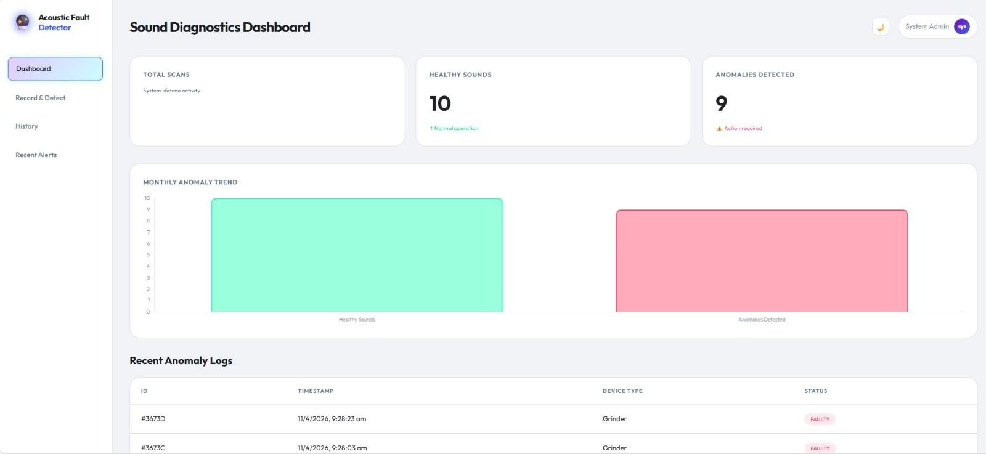

Figure (11.1) Dashboard Page

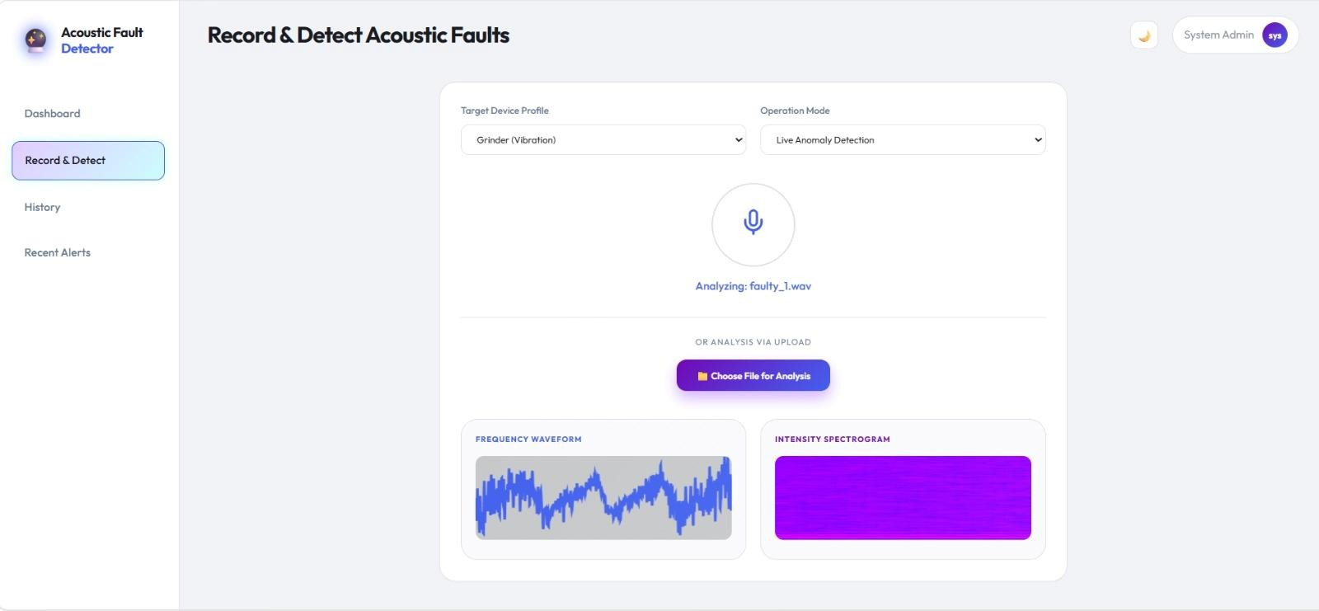

Figure (11.2) Record & Detect Page

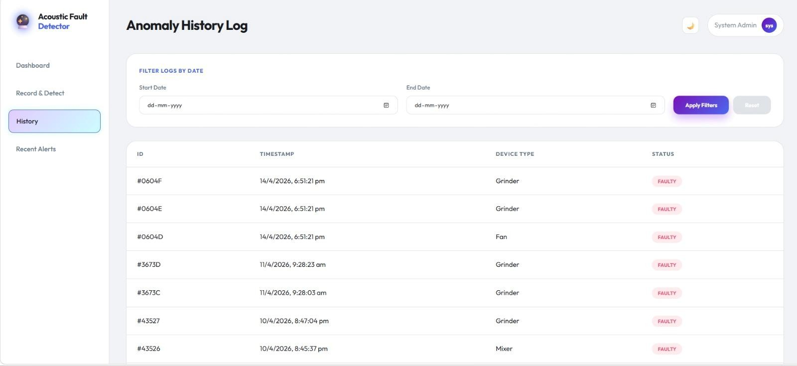

Figure (11.3) Anomaly History Log Page

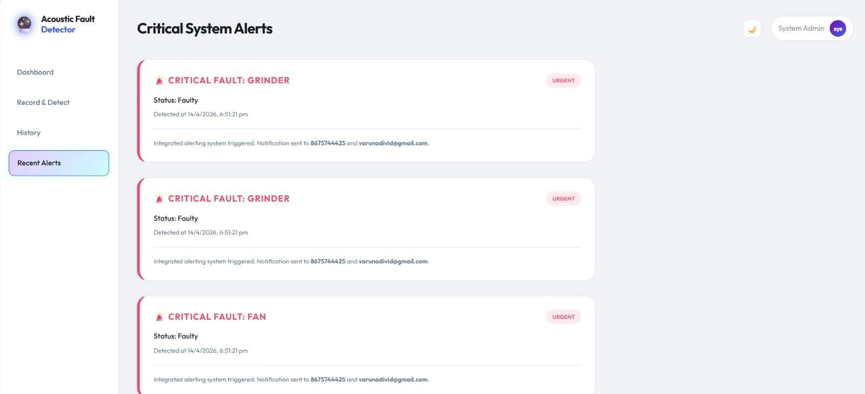

Figure (11.4) Recent Alerts Page

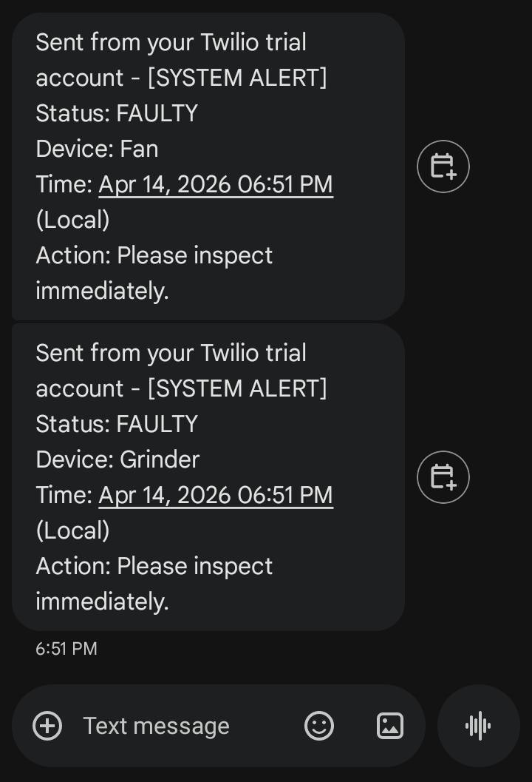

Figure (11.5) SMS Alert Notification

CONCLUSION
The Acoustic Fault Detection System presents an effective and user-friendly approach for monitoring machine health using sound analysis. By analyzing the unique audio patterns generated during machine operation, the system is capable of identifying abnormal conditions at an early stage. The integration of audio feature extraction techniques such as MFCC, ZCR, and spectral features with machine learning algorithms enables accurate classification of machine states into normal and faulty conditions.

The developed web-based dashboard provides a simple and interactive platform for users to upload or record audio, visualize waveform and spectrogram outputs, and view real-time detection results. In addition, the system enhances reliability by sending instant alerts through SMS and email whenever a fault is detected, ensuring timely action and reducing the risk of major failures.

Overall, this project demonstrates that acoustic-based fault detection is a cost- effective, non-invasive, and scalable solution for modern industries. It reduces dependency on manual monitoring and helps in minimizing downtime and maintenance costs. With further improvements and integration of real-time IoT sensors in the future, the system can be expanded into a fully automated smart monitoring solution for industrial applications.

REFERENCES
- Uzel, H., et al. (2026). Acoustic-Based Fault Diagnosis of Electric Motors Using Mel Spectrograms and CNN. Scientific Reports.
- Chandrakala, C. B., et al. (2026). Ball Bearing Fault Detection Using Acoustic-Based Machine Learning Approach. Scientific Reports.
- Hassan, A., et al. (2025). Physics-Guided Deep Learning for Acoustic- Based Fault Diagnosis. International Journal of Engine Research.
- Zhang, Y., et al. (2025). Rolling Bearing Fault Identification Using Multiscale CNN and Acoustic Emission Signals. Scientific Reports.2010
- Parmar, V., et al. (2025). Deep Learning Approach for Fault Severity Classification of Bearings. Scientific Reports.
- Wang, H., et al. (2025). Deep Learning-Driven Acoustic Signal Reconstruction in Energy Exploration. Frontiers in Earth Science.
- Singh, R., et al. (2025). Pipeline Defect Detection Using MFCC and LSTM Networks. Journal of Industrial Engineering Applications.
- Kumar, P., et al. (2025). Acoustic Defect Detection and Localization in Pipelines Using Deep Learning. Journal of Mechanical Systems.
- Y. Bai and T. Kuo, “Medication adherence by using a hybrid automatic re- minder machine,” in Proc. IEEE Int. Conf. Consum. Electron., 2016,pp. 573–574.
- McCarthy, R., et al. (2025). Machine Learning in Acoustics: A Comprehensive Review. npj Acoustics.
- Nguyen, T., et al. (2024). Acoustic Anomaly Detection Using Frequency Band Analysis. arXiv Preprint.

MAPPING OF THE PROJECT TO SUSTAINABLE DEVELOPMENT GOALS (SDGs)

The 17 Sustainable Development Goals (SDGs) adopted by the United Nations in 2015 aim to address global challenges such as poverty, inequality, climate change, environmental degradation, peace, and justice by 2030. This project titled “ACOUSTIC MACHINE FAULT DETECTION SYSTEM” is mapped to the following SDGs:


  - SDG 9 : Industry, Innovation and Infrastructure
This Project contributes to:

    - Developing an intelligent system for machine fault detection using acoustic analysis
    - Promoting innovative use of machine learning in industrial monitoring

Hence, the project aligns with SDG 9 by fostering innovation and strengthening digital infrastructure.

  - SDG 12 : Responsible Consumption and Production
This Project contributes to:
- Reducing machine breakdown and material wastage

- Supporting efficient use of industrial resources
Thus, the project supports SDG 12 by encouraging sustainable and efficient production practices.

PUBLICATION DETAILS
INTERNATIONAL CONFERENCE ON COMPUTING METHODOLOGIES AND COMMUNICATION – 2026


AI INTEGRATED IOT ENABLEDACOUSTICAND SENSOR FUSION FOR MACHINE FAULT DETECTION

¹Kiruthika Natarajan, ²Muthukrishnan P, ³Varuna Priya S, ⁴Ragunath R
¹²³⁴Department of Information Technology, Nandha Engineering College, Erode, India
¹kiruthikanatarajan18@gmail.com, ²muthukrishnan.it23@gmail.com, 3varunadivid@gmail.com, ⁴ragunathmecse@gmail.com

Abstract:
The proposed system, titled "AI Integrated IoT Enabled Acoustic and Sensor Fusion for Machine Fault Detection", is designed based on the "Artificial Intelligence" technology suitable for detecting the machine-level faults in home appliances like fan, mixer, grinder and so on. In addition to this, "Internet of Things" technology is also enabled in the system for its better connectivity to the cloud technology. It is composed of "Temperature Sensor, Vibration Sensor, Microphone Setup" with the "Web-Based Dashboard" for acoustic analytics purposes. The Arduino UNO serves as the core of the setup, controlling the acoustic defects in home appliances. The real-time sensed data are shared with the "Sensor Fusion" and "Preprocessing Unit" to detect machine defects, and the data are then examined using a "Machine Learning" algorithm. When the threshold limit is reached, it automatically transfers real-time alerts to the end users for the fast recovery of the appliances from the machine defects. On the other hand, the integration of the dashboard into the proposed work helps end users in many ways for the continuous monitoring and controlling of the process. It is programmed with the aid of the Python Programming language, and in addition to this, "Librosa, Numpy, Flask"

are inserted into the making of the dashboard.
Keywords: Acoustic, Sensor Fusion, Artificial Intelligence, Internet of Things, Temperature Sensor, Vibration Sensor, Microphone, Librosa

INTRODUCTION
"Machine Fault Detection" is a kind of process that helps to identify the abnormalities or failures that occur in machines like "Motors, Bearings, Gearboxes, Pumps", and so on. These defects are detected at an early stage to prevent the breakdowns, reduce maintenance costs and to improve safety levels. It is involved based on the monitoring machine conditions and detection conditions when the routine working of the machine is missing. This thing can be easily done with the aid of "Sensors", "Signal Processing", and "Machine Learning" technologies. The common level of machine faults detected in the machines is "Bearing Defects, Gear Wear or Gear Damage, Misalignment of Shaft, Imbalance level in Rotating Parts, Overheating, and Lubrication Failures". The types of Methods used to detect machine faults are "Traditional Methods, Signal Processing Techniques, Machine Learning-Based Detection", and the types
of maintenance are "Reactive Maintenance,

Preventive Maintenance, Predictive Maintenance". The proposed system is designed based on the “AI Technology” for the advanced level of machine fault detection in home appliances like “Fan, Mixer, Grinder, Washing Machine” and so on[8][9][12][14].

LITERATURE SURVEY
The author argues that implementing aerospace product development tests to detect loose-bolt failures increases the effectiveness of vibration assessments and may lead to potential damage to the machine. It also increases the risk of personal injury to end users and should be addressed with utmost care. The above issue can be easily addressed with the aid of a "Deep Learning" model, and it will be completely based on the real-time intelligent detection process, mainly for the bolt loosening faults[1]. This idea shows the importance of bearings and how they will play a significant role in the rotating machinery. As compared to the traditional analysis, the proposed idea, Acoustic Emission, helps to reach higher sensitivity to low levels of speed detection in rotating mechanical and it will be very helpful for early-level fault detection. It integrates the Kurtogram Method to examine the presence of defects in the bearings, which is
composed of autocorrelation functions[2]. The author says that the proposed work is based on the intelligent fault detection method designed mainly for transformers, which is based on multimodal fusion. It is integrated with the infrared image texture features, humidity information, and acoustic signals. On the other hand, the implementation of the digital twin model, the real-time monitoring and diagnosis of the faults for the transformer operating states are easily achieved[3]. The existance of the new acoustic feature representation is the proposed idea of the system that helps to detect faults present in the rotary machines by acoustic signals. Here, the acoustic signals include "Amplitude", "Frequency", and "Timbre" with the diagnostic features. The "Timbre" is the indicator of the abnormal operation of the machinery[4]. The author shares that the various levels of faults that occurred in the electrical machines cause a severe level of downtime and losses in the assets. Also suggests that the importance of the fault detection technologies by implementing in the industry increases the desirability, which helps to predict and prevent the occurrence of failures. The recent advancements in machine learning have enabled various data-driven models that identify the faults from the signals monitored in the motors[5].

PROPOSED SYSTEM
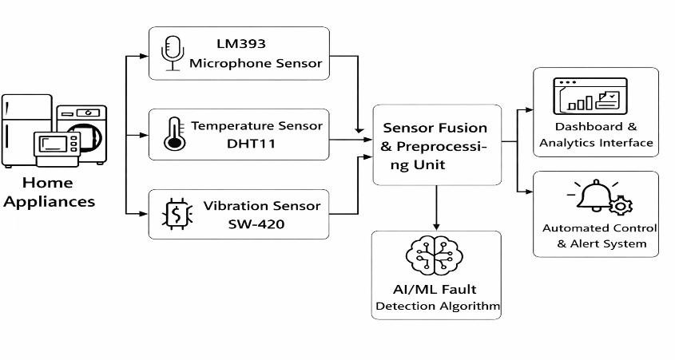

Fig 1.1 Block Illustration of Proposed Work

The proposed system works based on modules like "Acoustic Data Processing Module, Sensor Fusion & Fault Detection Module, IoT Monitoring & Alert Module", and helps in detecting the various levels of machine faults occurring in the home appliances. The Acoustic Data Processing Module helps to capture the machine sounds and extract the important audio features to identify the normal and abnormal sound patterns. The Sensor Fusion & Fault Detection Module combines acoustic data with vibration levels and temperature readings to accurately detect the machine faults occurring in the machines. The IoT Monitoring & Alert Module sends the real-time machine status updates to the end users through the web platform and triggers SMS alerts to the user's smartphone when a fault is detected. On the other hand, the installation of the "Machine Learning" algorithm aids in detecting machine faults in an advanced mode by using the various levels of libraries like "Librosa, Numpy, and Flask"[6][7][10][11].

HARDWARE IMPLEMENTATION

Temperature Sensor:
A "Temperature Sensor" is a kind of device that helps to measure the temperature level in an object or an environment, and it converted into readable signals. These signals help to easily monitor and control the systems, and the types of sensors are "Thermocouple, Resistance Temperature Detector, Thermistor, IC Temperature Sensors, and Infrared Temperature Sensor". The "Thermocouple" works based on the principle of voltage generated between two metals. This voltage can be generated due to the temperature difference between the two voltage levels.
"RTD" measures the temperature based on the change in the electrical resistance, and it delivers very accurate and stable outputs to the end users. "PTC" and "NTC" are the types of thermistor temperature sensors, and here "PTC" stands for "Positive Temperature Sensor" and "NTC" stands for "Negative Temperature Sensor".
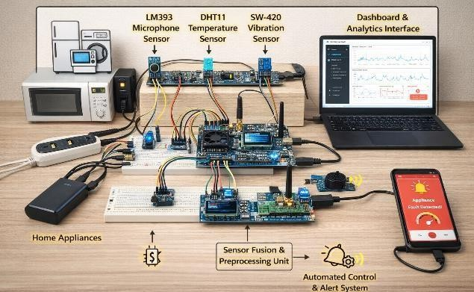
Fig 1.2 Hardware Implementation of Proposed Idea

Vibration Sensor:
A "Vibration Sensor" is a type of device that aids in detecting and measuring the vibrations, such as oscillations or movements, present in machines, structures, or environments. These sensors convert "Mechanical Motion" into "Electrical Signals", and they can be analysed for motoring purposes or fault detection purposes. The types of vibration sensors are "Piezoelectric Vibration Sensor, Accelerometer, Velocity Sensor, Displacement Sensor, MEMS Vibration Sensor", and they are used based on the different requirements. "Piezoelectric Vibration Sensor" works based on the "Piezoelectric Sensor", and it will be used in the fields of industrial monitoring and machinery fault detection. "Accelerometer" is used to measure the vibration levels based on the acceleration caused by the vibrations.

Microphone Sensor:

A "Microphone Sensor" is an electronic device that detects the sound waves, i.e., audio signals from the devices and completely converted into electrical signals. These types of sensors are widely utilised in the fields of electronics, IoT, and Embedded Systems for the purpose of sound detection and analysis. The types of
microphone sensors are "Analogue Microphone Sensor, Digital Microphone Sensor, Electret Microphone, and MEMS Microphone". The best example for the Analogue Microphone Sensor is "KY-038 Sensor Module" and for the Digital Microphone Sensor is "KY-037 Sensor Module"[13][15].

RESULT AND DISCUSSION
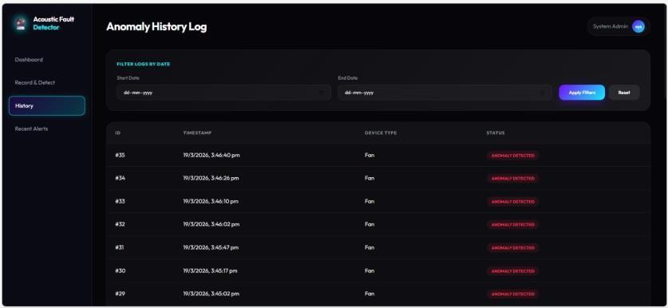
Fig 1.3 Acoustic Fault Log
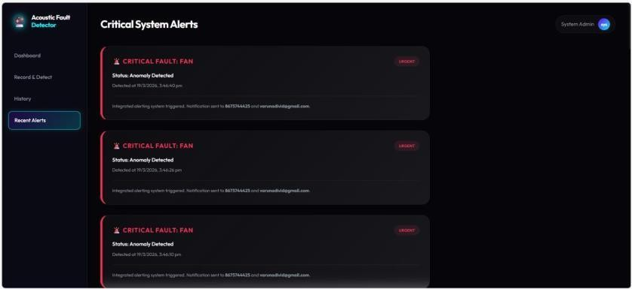
Fig 1.4 System Fault Alerts
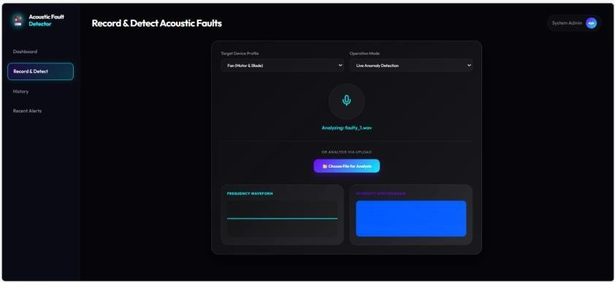
Fig 1.5 Recording Acoustic Faults

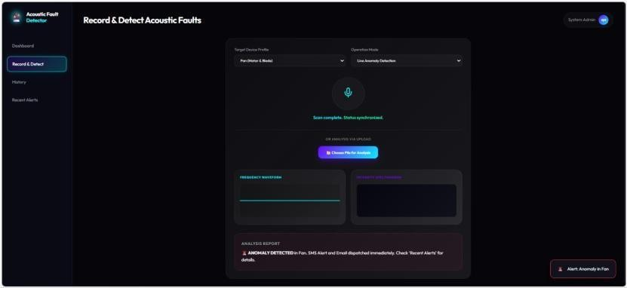
Fig 1.6 Detecting Acoustic Faults
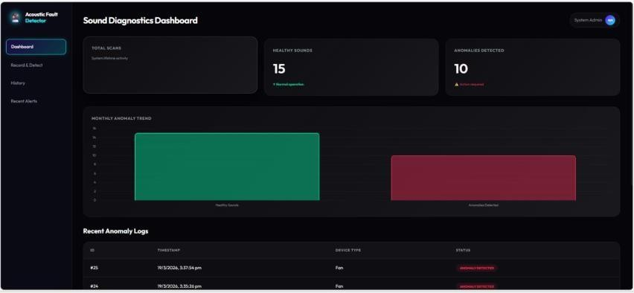
Fig 1.7 Acoustic Dashboard

The above figures show that the real-time detection of the machine fault is possible in home appliances like a “Fan”. Figure 1.3 shows that the acoustic fault occurred in the fan, and it was detected at what time and the entire history log was displayed here. Figure 1.4 shows that the real-time fault was detected in the fan, and it was alerted to the end users with an SMS to their smartphones. Figure 1.5 displays the recording module of the acoustic faults of the home appliances. The fault was easily found by the dashboard by clearly examining the sounds from the operating machines of the appliances. This can be easily achieved with the aid of “ML Algorithms”. Figure 1.6 shows that the detection of the acoustic faults in the appliances by playing the recorded fault sounds randomly, by comparing them to the
trained models developed by the end user. And finally, Figure 1.7 displays the real- time acoustic dashboard developed by the programmer, and it clearly shows the “Healthy Sounds” and “Anomaly Sounds” with reference to the end users. The entire dashboard is created based on the “Python Programming” language, and in addition to this, the “ML Algorithms” are also integrated into the proposed system. The “Librosa” model is for the purpose of audio processing and feature extraction. The “NumPy” model is for numerical operations as well as audio signal processing. The “Flask” model is used for creating the featured web dashboard for detecting the real-time acoustics in the home appliances and it can be easily resolved by the end users.

CONCLUSION AND FUTURE SCOPE
In conclusion, the proposed work will be very useful for the end users by detecting the real-time acoustic faults in all kinds of home appliances. The web dashboard is designed based on the Python programming language, integrated with the “AI Technology” aids in clearly detecting machine faults and alerts end users to examine it on an earlier stage. By making this, the life span of the home appliances will be increased for a long time, and also it saves the running cost for the end users. The software implementation of the proposed idea is completed and displayed here, and the hardware implementation is in progress. Soon it will be launched for the end users, and it will be completely available for you to save the lives of the machines as well as your valuable time.
In future, the proposed work will be integrated with the advanced AI techniques for better acoustic detection of appliances. As well as the system will be expanded to detect the “Industrial Machines” for saving them from the real-time poor acoustic faults.

REFERENCES
- Y. Liu et al., “Research on bolt loosening fault detection method in random vibration test based on acoustic event detection,” Proc. 2nd Int. Conf. Pattern Recognition, Machine Vision and Intelligent Algorithms (PRMVIA), Changsha, China, 2024, pp. 8–11, doi: 10.1109/PRMVIA63497.2024.00008.

- D. Liu et al., “An optimized kurtogram method for early fault detection of rolling element bearings using acoustic emission,” Proc. Int. Conf. Information Systems and Computer Aided Education (ICISCAE), Changchun, China, 2018, pp. 365–370, doi: 10.1109/ICISCAE.2018.8666929.
- Z. Xu et al., “Intelligent fault detection for transformers based on multimodal fusion,” Proc. 11th Int. Symp. Sensors, Mechatronics and Automation System (ISSMAS), Zhuhai, China, 2025, pp. 68–71, doi: 10.1109/ISSMAS65783.2025.11103030.

- K. Minemura, T. Ogawa, and T. Kobayashi, “Acoustic feature representation based on timbre for fault detection of rotary machines,” Proc. Int. Conf. Sensing, Diagnostics, Prognostics, and Control (SDPC), Xi’an, China, 2018,
pp. 302–305, doi: 10.1109/SDPC.2018.8664991.

- H. Zhang and B. Wang, “Supervised contrastive learning for electric motor bearing fault detection,” Proc. Int. Conf. Electrical Machines (ICEM), Torino, Italy, 2024, pp. 1–7, doi: 10.1109/ICEM60801.2024.10700325.

- N. Yordanov et al., “Fault detection in electric motors using acoustic signals and image classification,” Proc. Int. Conf. Applied and Theoretical Electricity (ICATE), Craiova, Romania, 2024, pp. 1–6, doi: 10.1109/ICATE62934.2024.10749208.
- A. T. Oo et al., “Induction motor fault detection and classification using fusion features and machine learning techniques,” Proc. 26th Int. Conf. Digital Signal Processing and its Applications (DSPA), Moscow, Russia, 2024, pp. 1–6, doi: 10.1109/DSPA60853.2024.10510077.

- C.-Y. Hsiao and S. M. Htet, “Acoustic fault detection in brushless DC motors using machine learning for predictive maintenance,” Proc. IEEE Int. Conf. Recent Advances in Systems Science and Engineering (RASSE), Taichung, Taiwan, 2024, pp. 1–4, doi: 10.1109/RASSE64357.2024.10773692.

- M. A. R. Alicando et al., “Bearing fault
detection of a single-phase induction motor

using using acoustic and vibration analysis through Hilbert–Huang transform,” Proc. IEEE Int. Conf. HNICEM, Manila, Philippines, 2021,
pp. 1–6, doi: 10.1109/HNICEM54116.2021.9732034.

- L. Imtiaz et al., “AI-assisted fault diagnosis in rotating machines using acoustic signals and linear-frequency cepstral coefficients,” Proc. Int. Conf. Engineering and Computing Technologies (ICECT), Islamabad, Pakistan, 2025, pp. 1–
6, doi:
10.1109/ICECT66235.2025.11381695.

- S. Mukhopadhyay et al., “Robust fault diagnostics of industrial motors using signal- to-image approaches and multi-task transformers,” Proc. IEEE Int. Conf. Control, Instrumentation, Energy & Communication (CIEC), Kolkata, India, 2024, pp.
129–134, doi:
10.1109/CIEC59440.2024.10468531.
- S. Dey and S. Banerjee, “An edge-AI and IoT-based predictive maintenance device for electric motors via multimodal sensor fusion,” Proc. Int. Conf. IEMECON, Jaipur, India, 2025,
pp. 1–6, doi: 10.1109/IEMECON69302.2025.11365866.
- S. Mehta and N. Rao, “Enhanced fault detection in semiconductor wafers using multisensor data fusion and machine learning techniques,” Proc. Int. Conf. Intelligent Cyber Physical Systems and IoT (ICoICI), Coimbatore, India, 2024, pp. 631–637, doi: 10.1109/ICoICI62503.2024.10696519.

- S. M. Saravanan et al., “Sensor failure identification using wavelet performance analysis for WSN-based wind turbine monitoring,” Int. J. Industrial Engineering: Theory, Applications and Practice, vol. 30, no. 3, 2023.

- M. F. Bangash et al., “AI-based multi- signal fault diagnosis of induction motors,” IEEE Access, vol. 13, pp. 213377–213395,
2025, doi:
10.1109/ACCESS.2025.3638716

